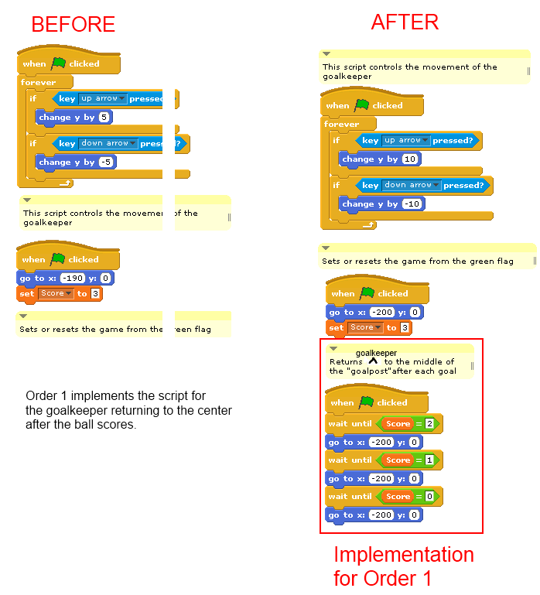Order 1: Implementation of the goalkeeper returning to the middle of the goalpost after Slytherin scores.

Difficulty Rating

|  |  |  |  |  |
| --- | --- | --- | --- | --- |
| Very easy | Easy | Medium | Hard | Very Hard |
|  |  | x |  |  |

Reason: The implementation took a long time to figure out as the developer was not familiar with the syntax used in Scratch. He was thinking of referencing the quaffle in the goalkeeper’s scripts but was not within Scratch’s programming parameters. Instead, the ‘wait until’ function was used.

Order 2: Implementation of the quaffle returning to the center ring of the field.

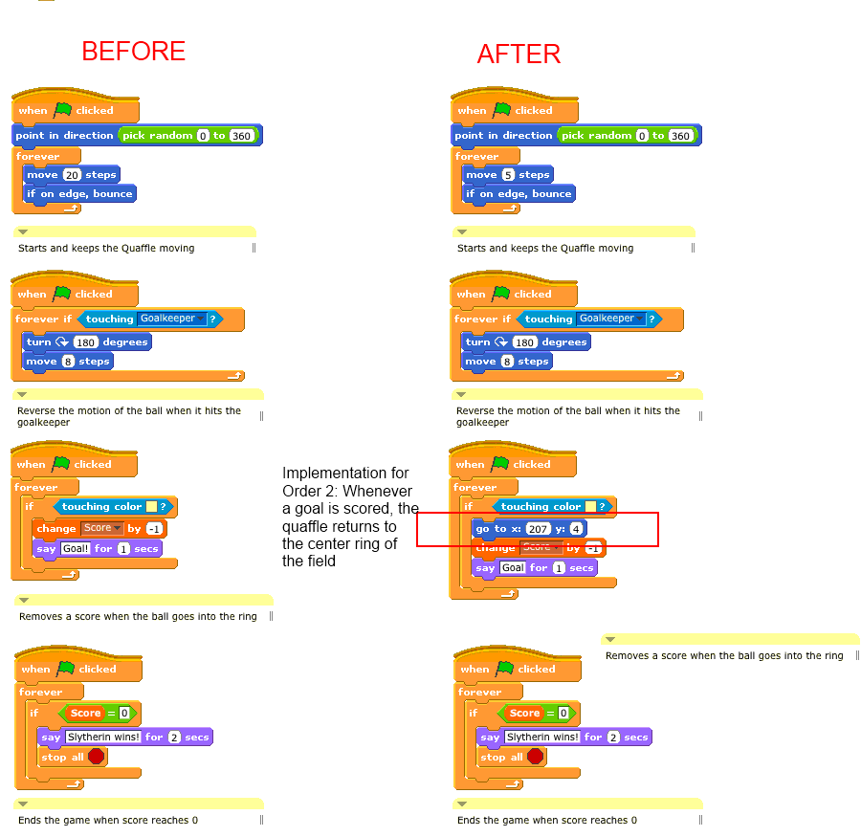 Difficulty Rating

|  |  |  |  |  |
| --- | --- | --- | --- | --- |
| Very easy | Easy | Medium | Hard | Very Hard |
|  |  | x |  |  |

Reason: The developer working on this implementation was not familiar with Scratch, which made things slightly more complicated. After trying multiple implementations, this one worked.

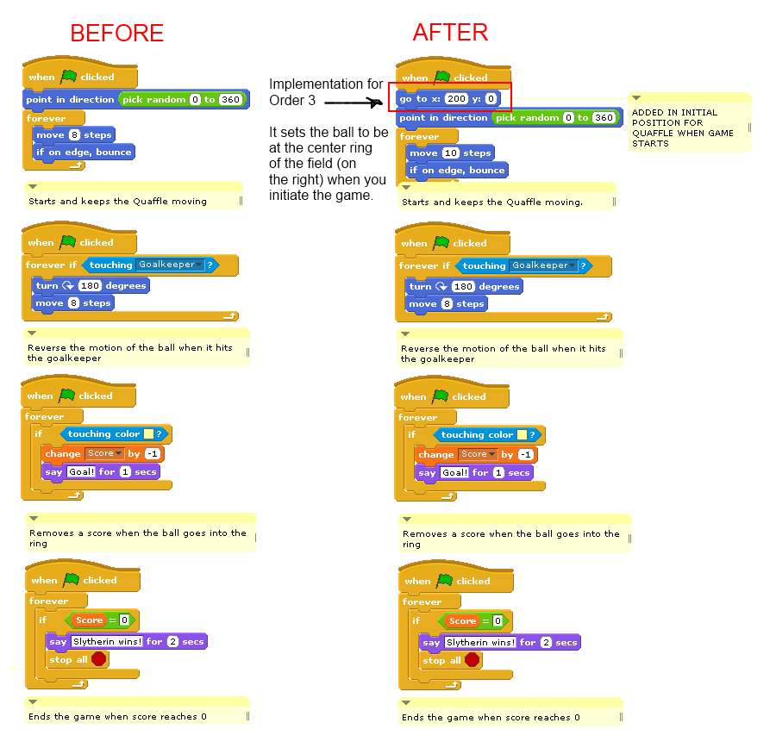Order 3: Implementation of the quaffle being put in the center ring of the field when the field starts.

Difficulty Rating

Difficulty Rating

|  |  |  |  |  |
| --- | --- | --- | --- | --- |
| Very easy | Easy | Medium | Hard | Very Hard |
| x |  |  |  |  |

Reason: Putting the starting location for the goal keeper was very simple.